Name: Table 1 Couple 1
 | 1 | 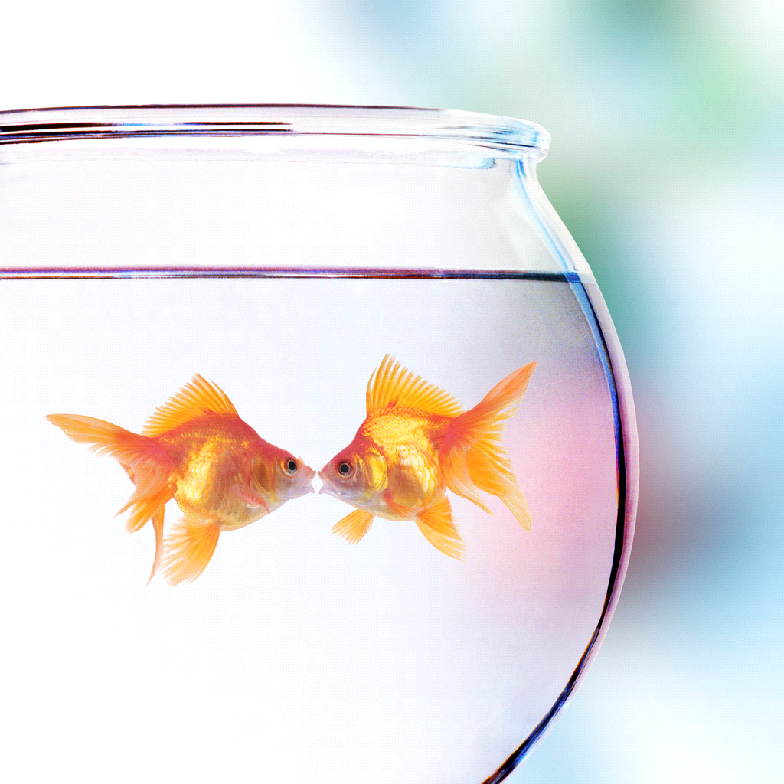2 | 3 | 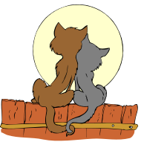4 | 5 |   6
Round
1
Round
2
Round
3
Wins ______ Losses ______ Bunkos ______

Name: Table 1 Couple 1
 | 1 | 2 | 3 | 4 | 5 | 6
Round
1
Round
2
Round
3
Wins ______ Losses ______ Bunkos ______

Name: Table 1 Couple 2
 | 1 | 2 | 3 | 4 | 5 | 6
Round
1
Round
2
Round
3
Wins ______ Losses ______ Bunkos ______
Name: Table 1 Couple 2
 | 1 | 2 | 3 | 4 | 5 | 6
Round
1
Round
2
Round
3
Wins ______ Losses ______ Bunkos ______

Name: Table 2 Couple 1
 | 1 | 2 | 3 | 4 | 5 | 6
Round
1
Round
2
Round
3
Wins ______ Losses ______ Bunkos ______

Name: Table 2 Couple 1
 | 1 | 2 | 3 | 4 | 5 | 6
Round
1
Round
2
Round
3
Wins ______ Losses ______ Bunkos ______
Name: Table 2 Couple 2
 | 1 | 2 | 3 | 4 | 5 | 6
Round
1
Round
2
Round
3
Wins ______ Losses ______ Bunkos ______

Name: Table 2 Couple 2
 | 1 | 2 | 3 | 4 | 5 | 6
Round
1
Round
2
Round
3
Wins ______ Losses ______ Bunkos ______

Name: Table 3 Couple 1
 | 1 | 2 | 3 | 4 | 5 | 6
Round
1
Round
2
Round
3
Wins ______ Losses ______ Bunkos ______
Name: Table 3 Couple 1
 | 1 | 2 | 3 | 4 | 5 | 6
Round
1
Round
2
Round
3
Wins ______ Losses ______ Bunkos ______

Name: Table 3 Couple 2
 | 1 | 2 | 3 | 4 | 5 | 6
Round
1
Round
2
Round
3
Wins ______ Losses ______ Bunkos ______

Name: Table 3 Couple 2
 | 1 | 2 | 3 | 4 | 5 | 6
Round
1
Round
2
Round
3
Wins ______ Losses ______ Bunkos ______
Name: Table 4 Couple 1
 | 1 | 2 | 3 | 4 | 5 | 6
Round
1
Round
2
Round
3
Wins ______ Losses ______ Bunkos ______

Name: Table 4 Couple 1
 | 1 | 2 | 3 | 4 | 5 | 6
Round
1
Round
2
Round
3
Wins ______ Losses ______ Bunkos ______

Name: Table 4 Couple 2
 | 1 | 2 | 3 | 4 | 5 | 6
Round
1
Round
2
Round
3
Wins ______ Losses ______ Bunkos ______
Name: Table 4 Couple 2
 | 1 | 2 | 3 | 4 | 5 | 6
Round
1
Round
2
Round
3
Wins ______ Losses ______ Bunkos ______

Name: Table 5 Couple 1
 | 1 | 2 | 3 | 4 | 5 | 6
Round
1
Round
2
Round
3
Wins ______ Losses ______ Bunkos ______

Name: Table 5 Couple 1
 | 1 | 2 | 3 | 4 | 5 | 6
Round
1
Round
2
Round
3
Wins ______ Losses ______ Bunkos ______
Name: Table 5 Couple 2
 | 1 | 2 | 3 | 4 | 5 | 6
Round
1
Round
2
Round
3
Wins ______ Losses ______ Bunkos ______

Name: Table 5 Couple 2
 | 1 | 2 | 3 | 4 | 5 | 6
Round
1
Round
2
Round
3
Wins ______ Losses ______ Bunkos ______

Name: Table 6 Couple 1
 | 1 | 2 | 3 | 4 | 5 | 6
Round
1
Round
2
Round
3
Wins ______ Losses ______ Bunkos ______
Name: Table 6 Couple 1
 | 1 | 2 | 3 | 4 | 5 | 6
Round
1
Round
2
Round
3
Wins ______ Losses ______ Bunkos ______

Name: Table 6 Couple 2
 | 1 | 2 | 3 | 4 | 5 | 6
Round
1
Round
2
Round
3
Wins ______ Losses ______ Bunkos ______

Name: Table 6 Couple 2
 | 1 | 2 | 3 | 4 | 5 | 6
Round
1
Round
2
Round
3
Wins ______ Losses ______ Bunkos ______

